1. **Area of Rectangle**

w = (5)

a = (6)

print( 'Area of Rectangle i.e lenth*breadth: ',(w*a))  
  
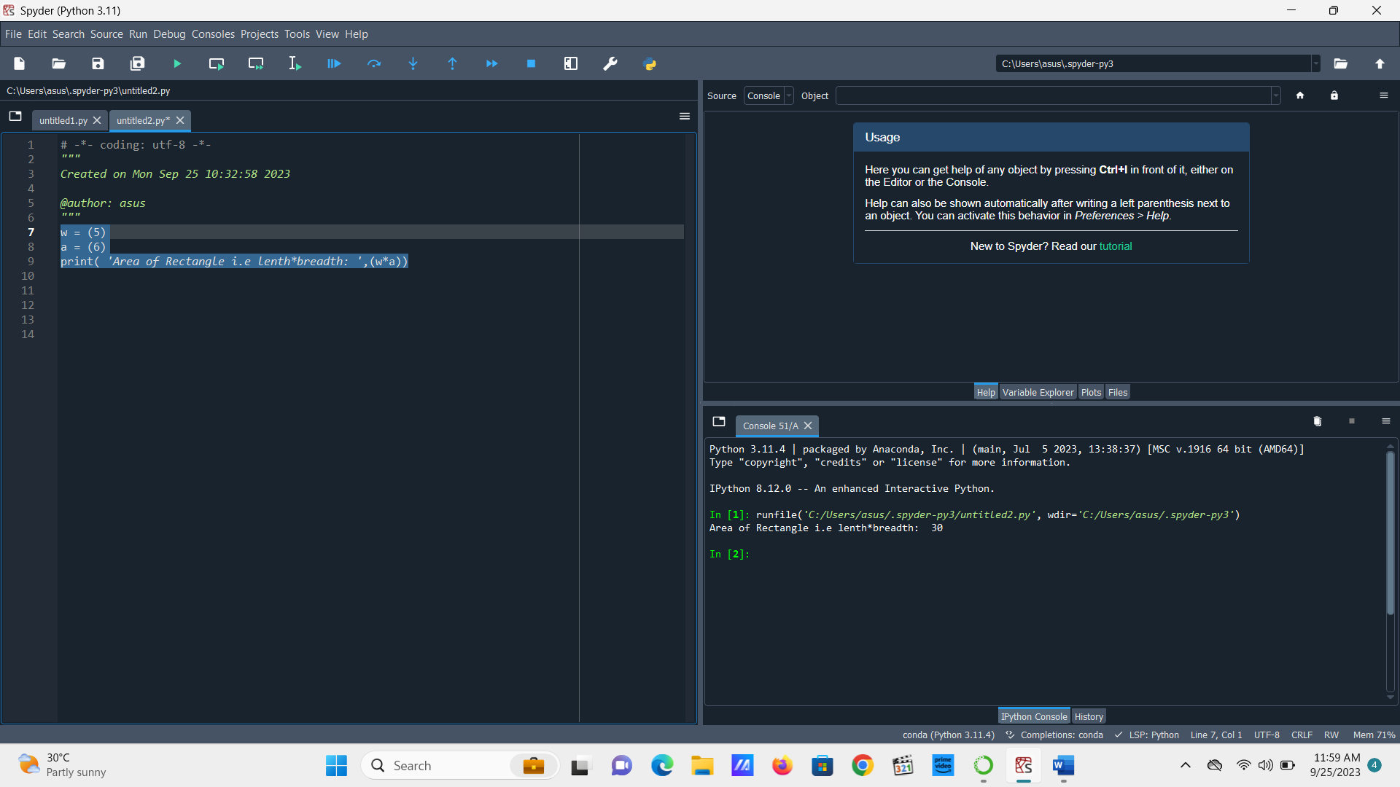

1. **Area of Square**

w = (5)

print( 'Area of Square i.e (SidexSide): ',(w**2))

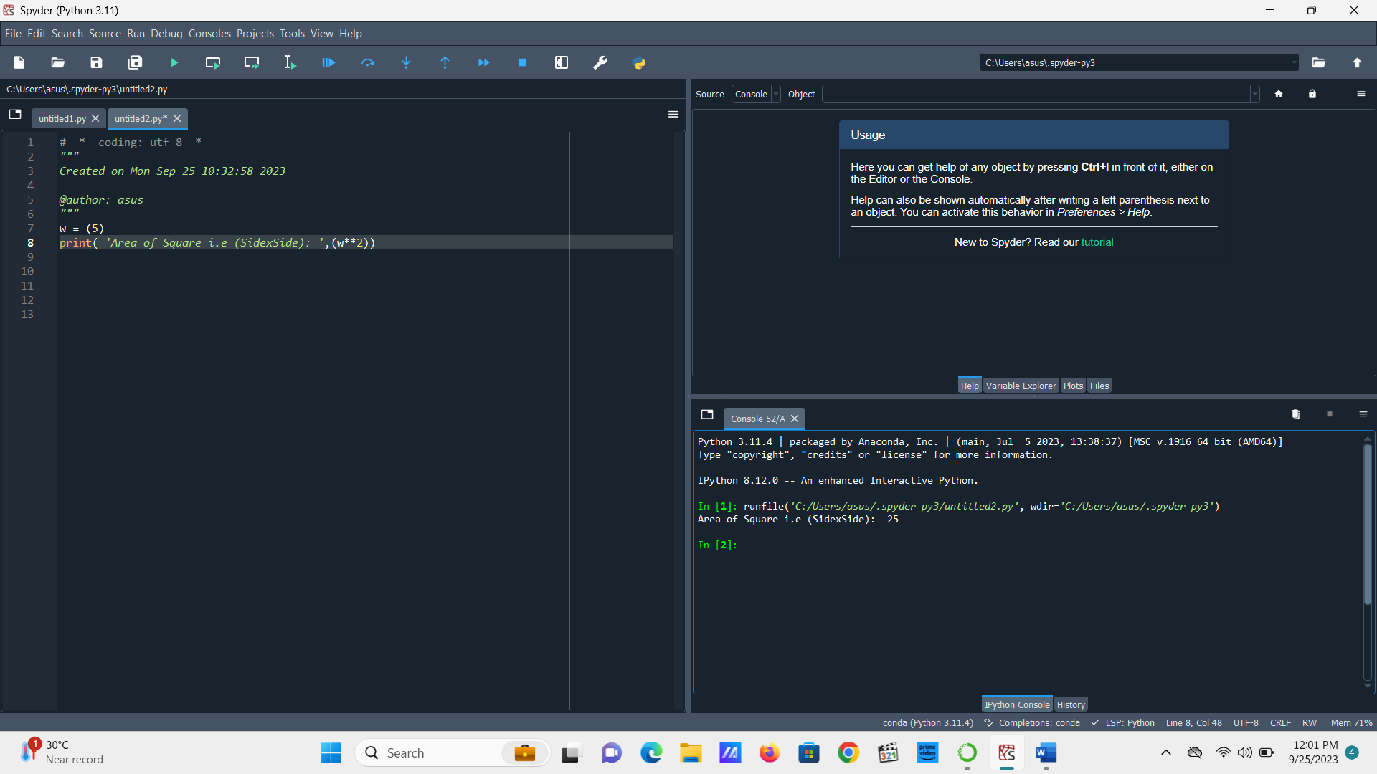

**3. Welcome to Amity (String)**

N= str('Welcome Ayush to Amity')

print (N)

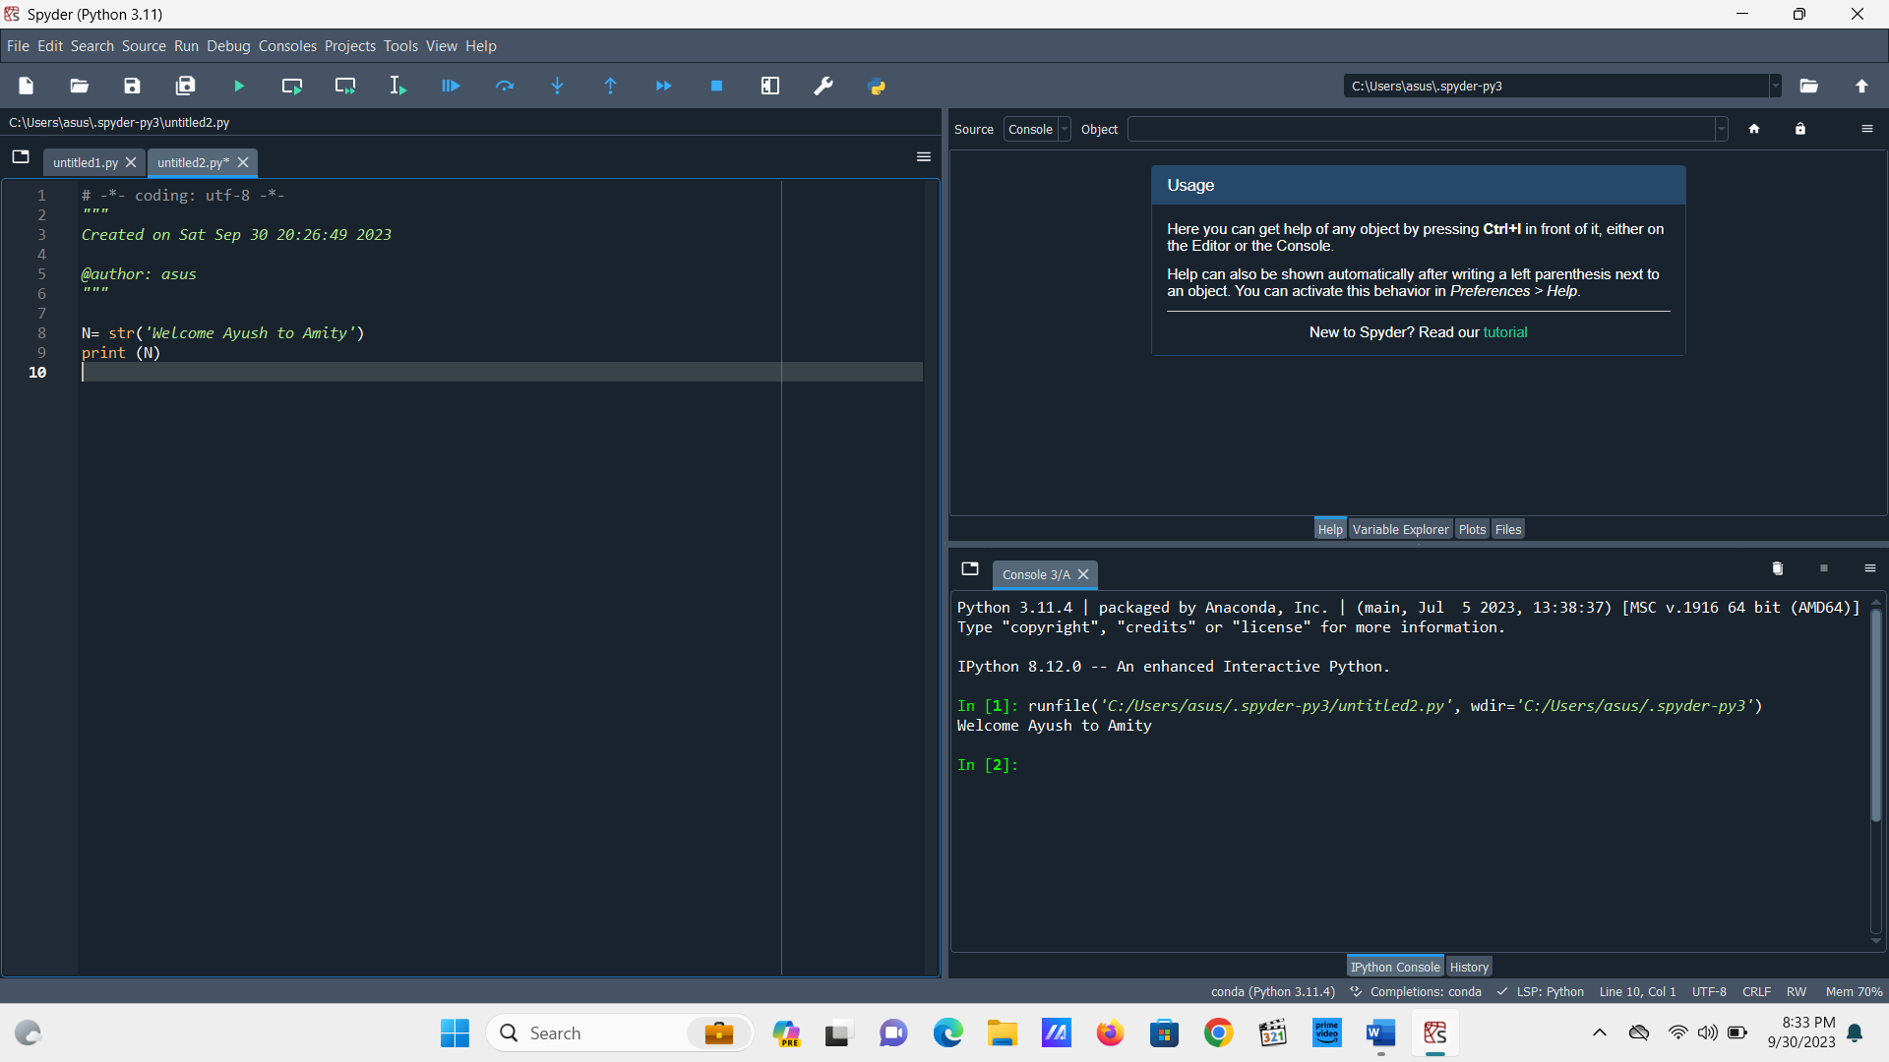

**4. Welcome By String and User Input**

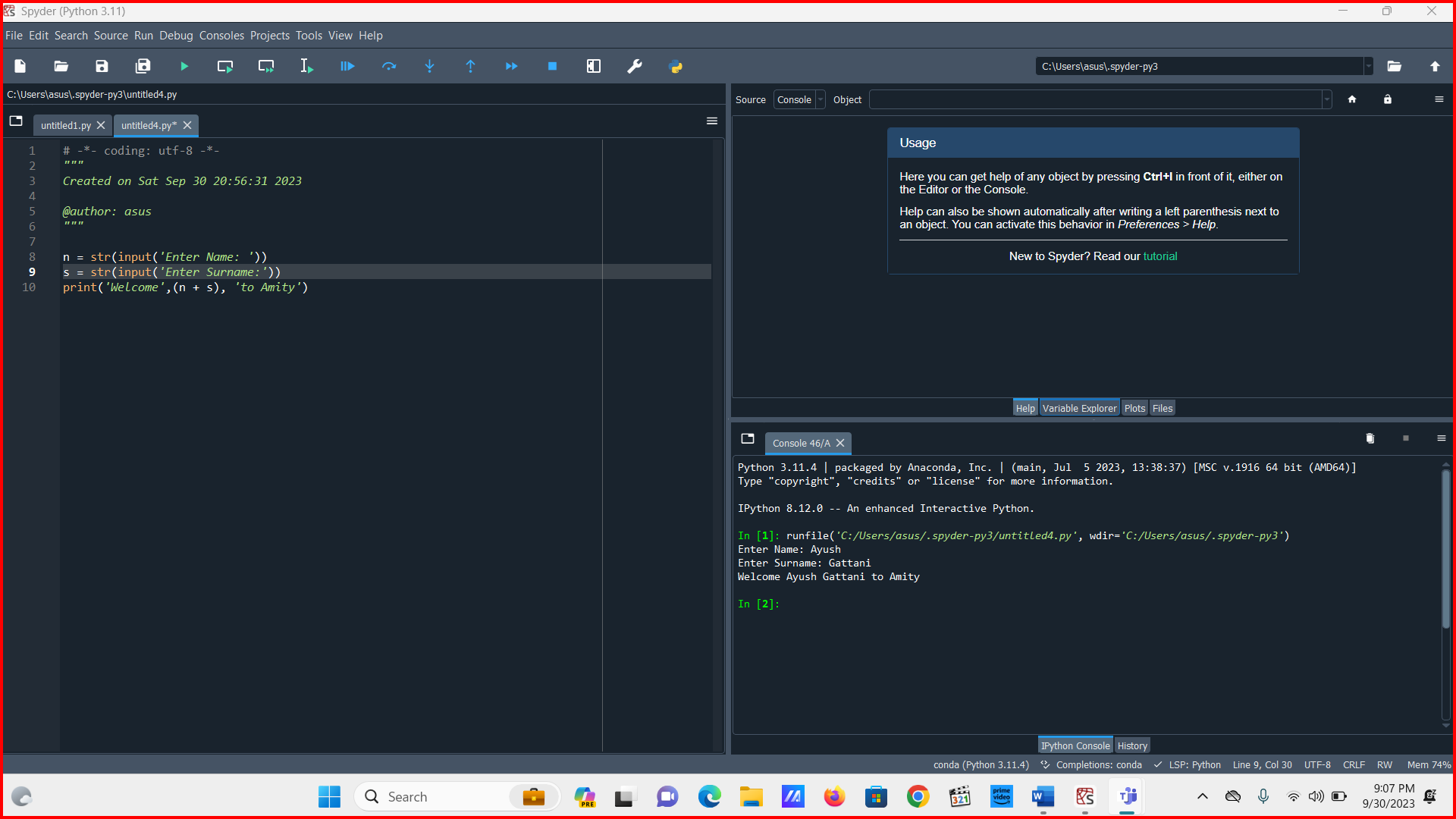

**5. Area of Rectangle by User Input**   
  
L = int(input('Enter the length: '))

B = int(input('Enter the Breadth: '))

print('Area of Rectangle', 'is', (L*B))

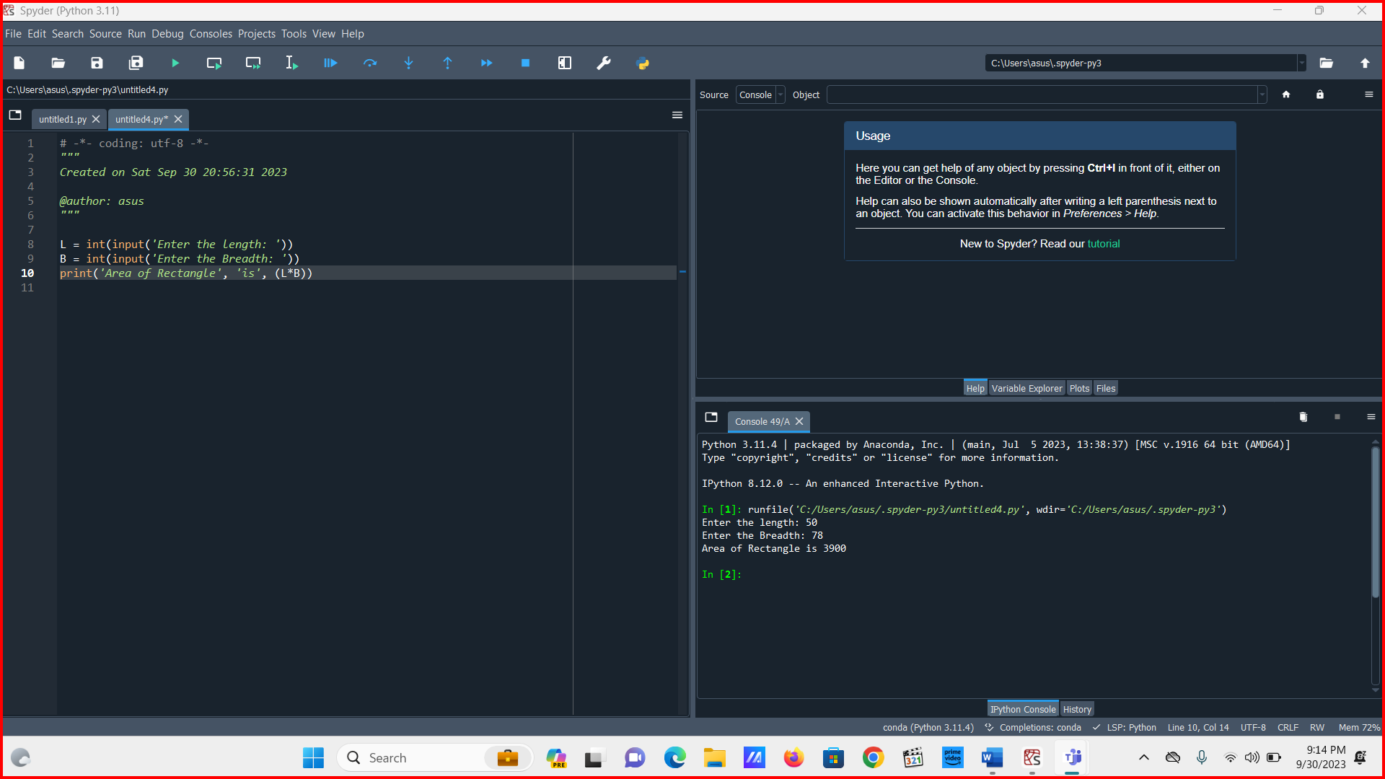

**6. Area of square by User Input**

S = int(input('Enter the Side: '))

print('Area of Square', 'is', (S*S))

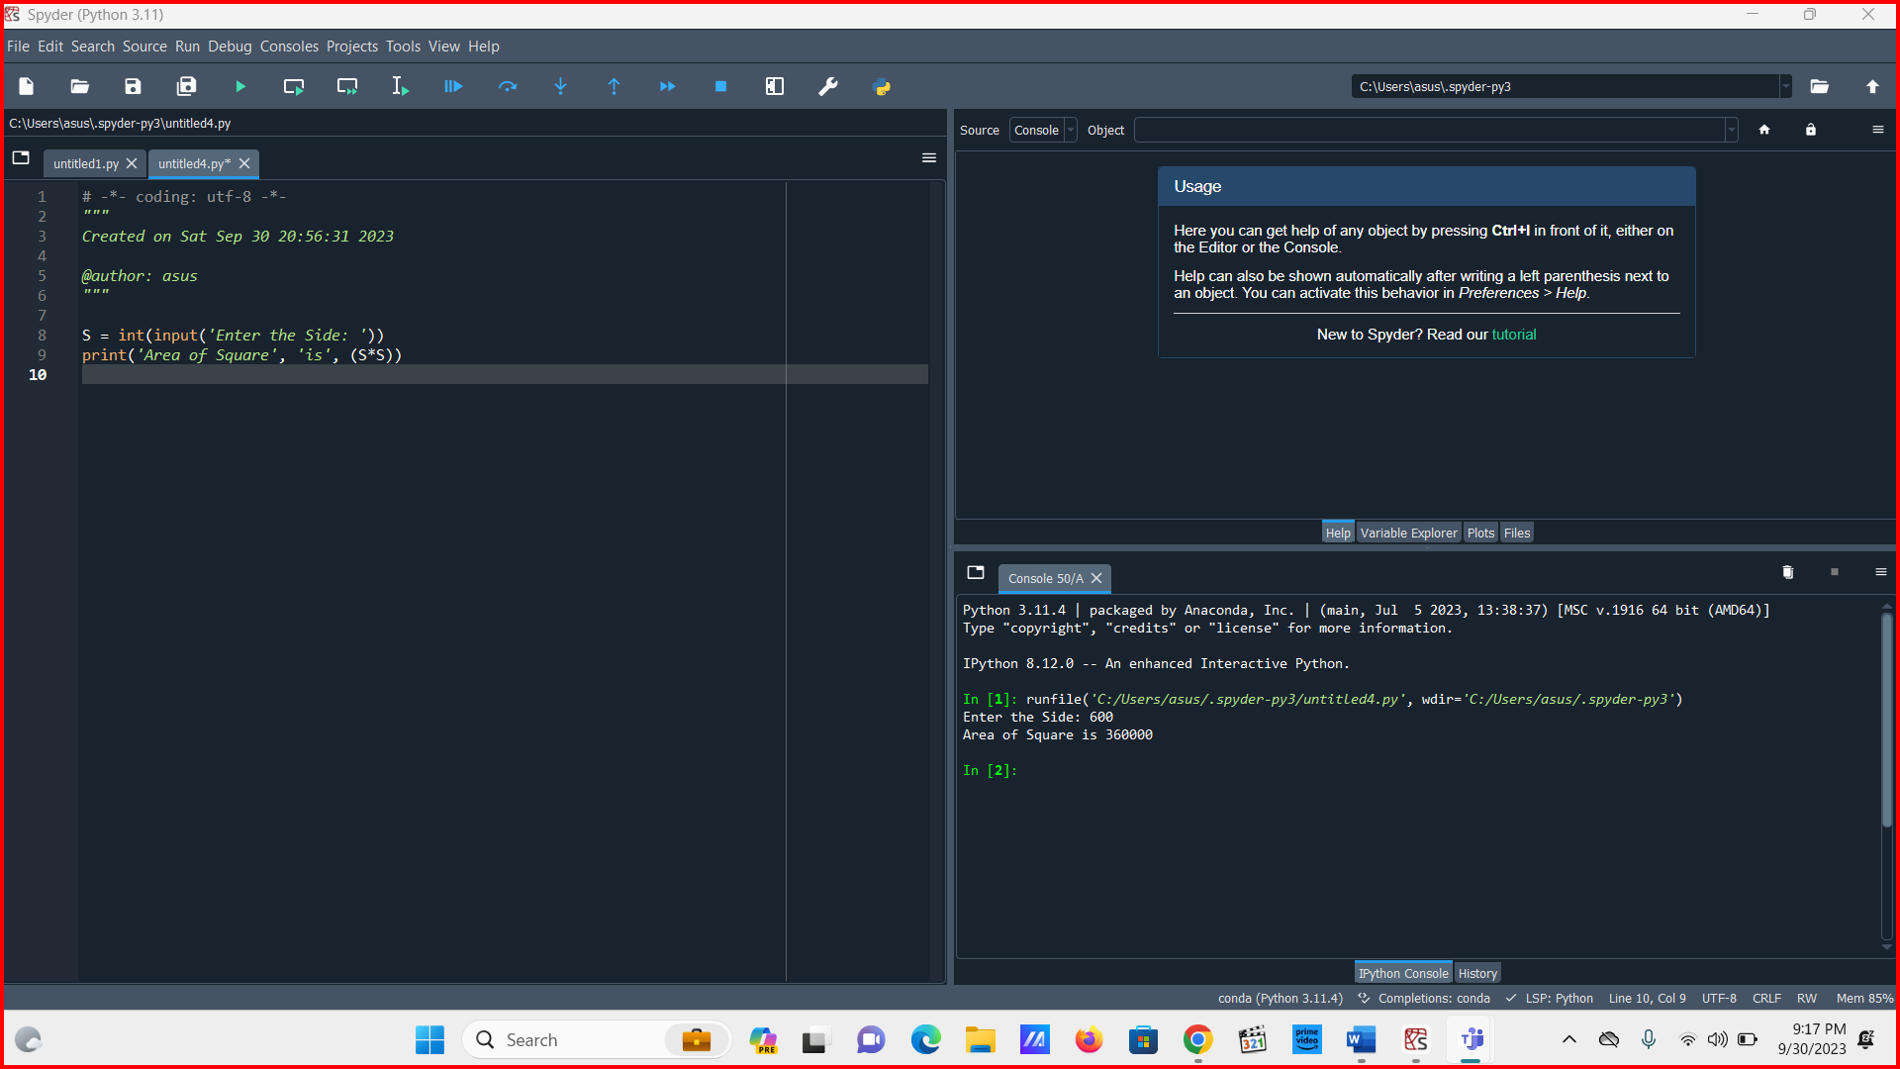

**7. Conversion of m/s to km/hr**

S = int(input('Enter the Speed in m/s: '))

print('Speed in km/hr will be', (S*3.6))

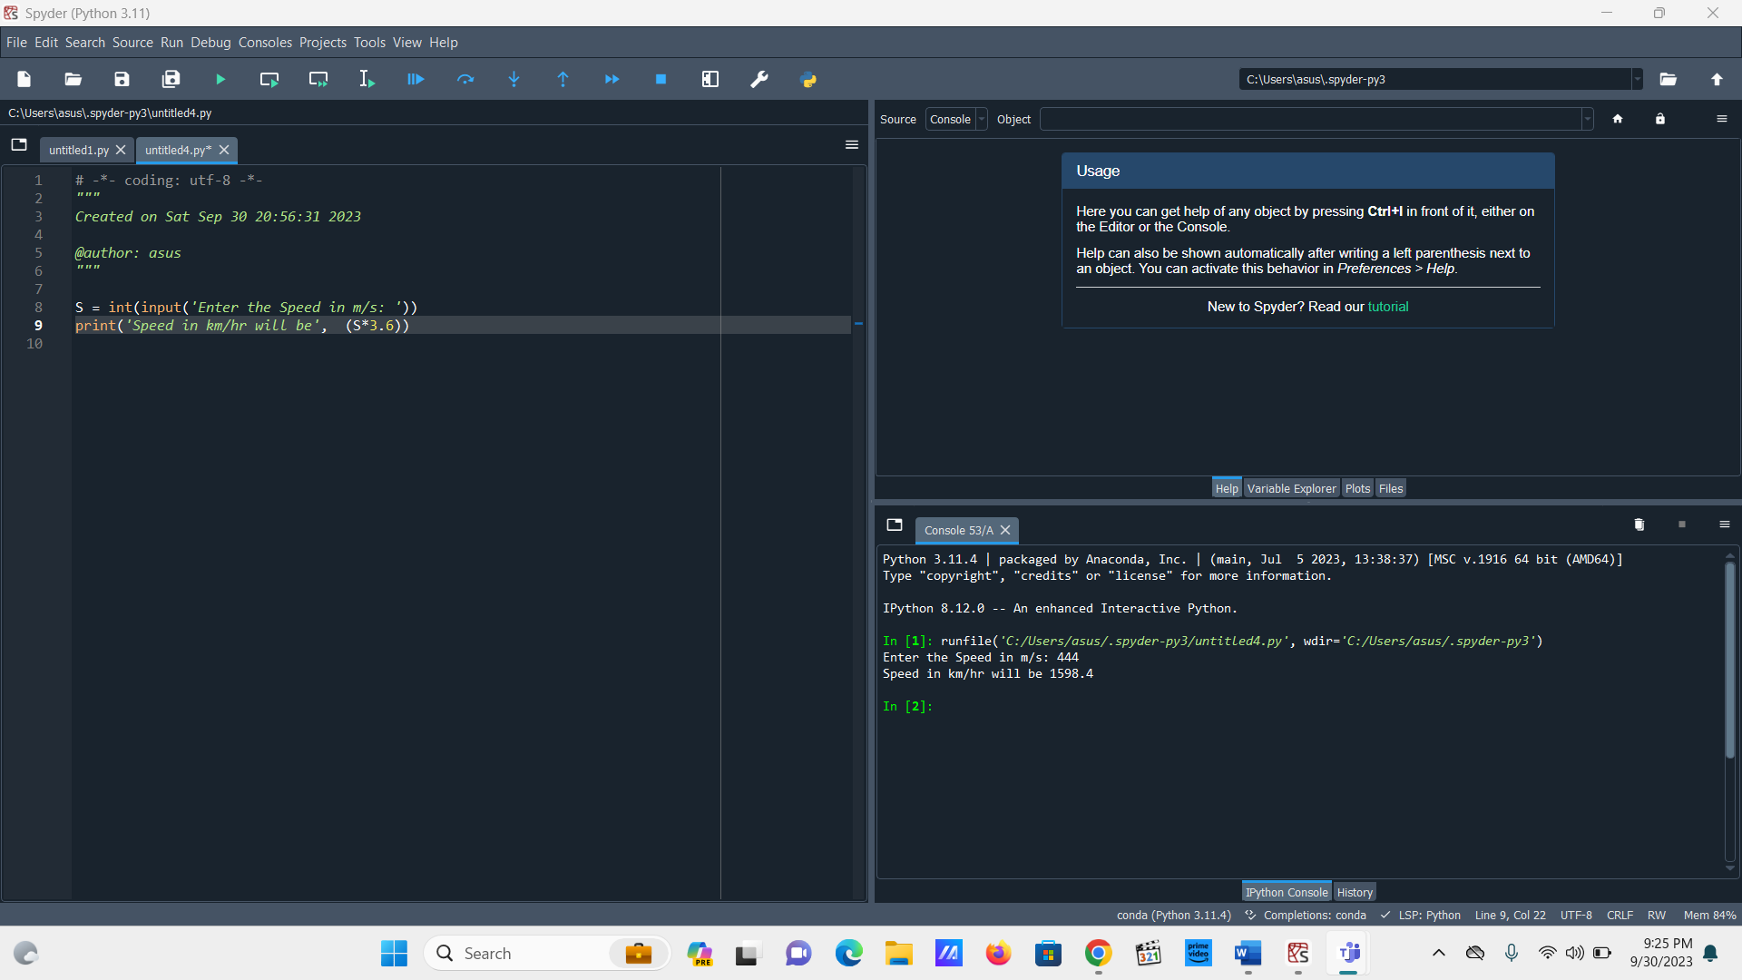

**8. Temperature Conversion**

T = int(input('Enter the Temperature in Celsius (°c): '))

print('Temperature in fahrenheit(°f) is : ', (( T * 9/5) + 32))

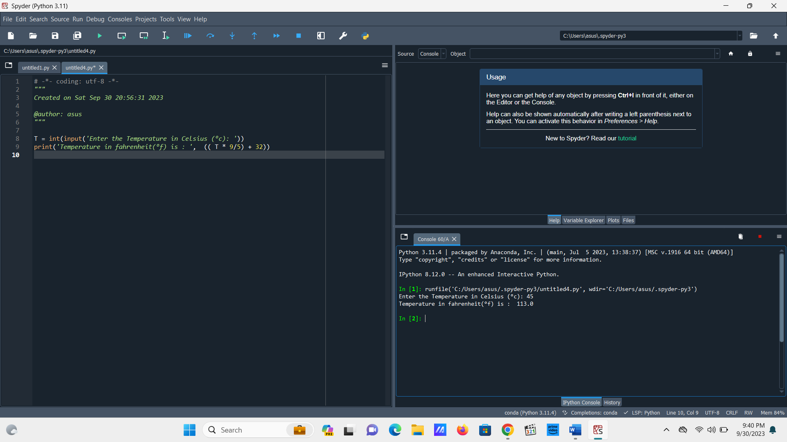

**9. Pieces of Paper**

P= int(input('Enter the Number of pieces: '))

K= (2**P)

print('Total number of pieces after tearing will be :',K)

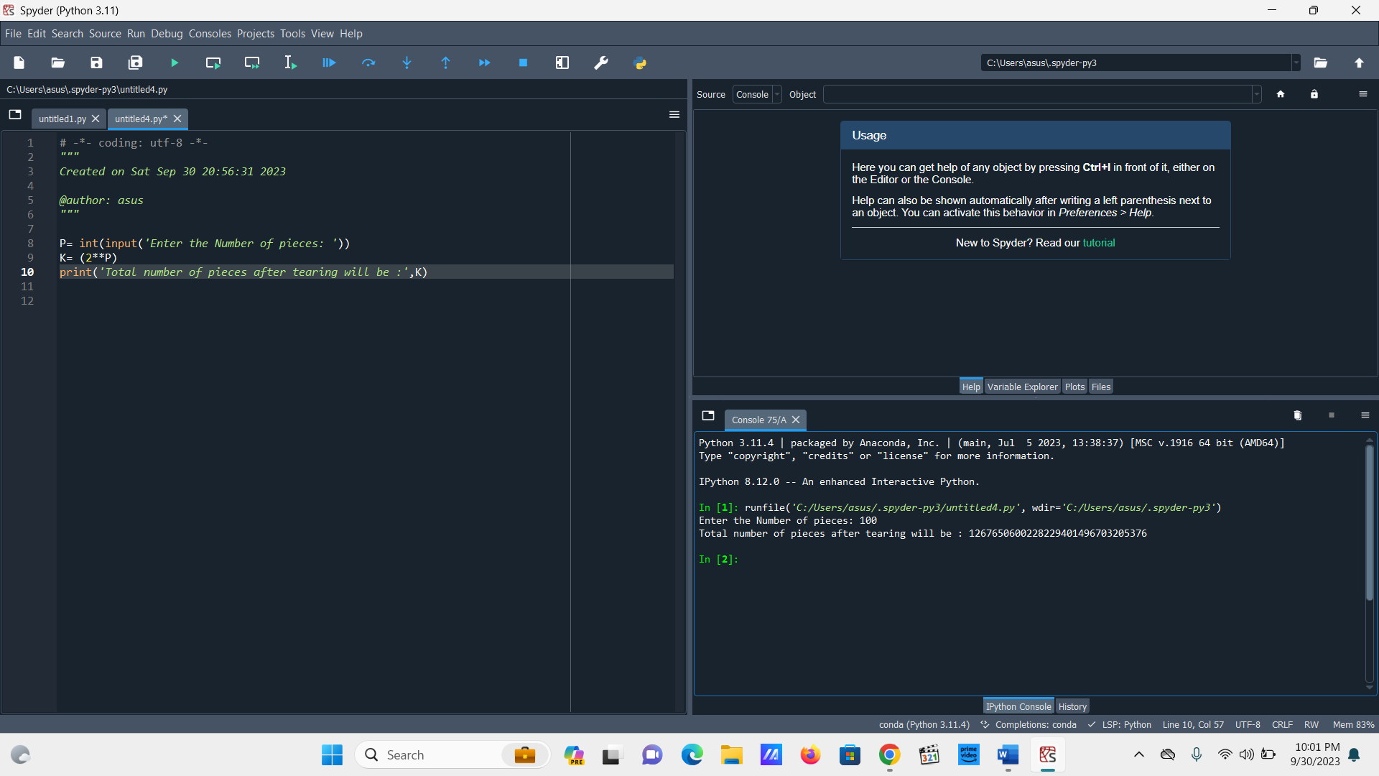

**10. Addition**

**a= int(4)**

**b= int(5)**

**print (a+b)**

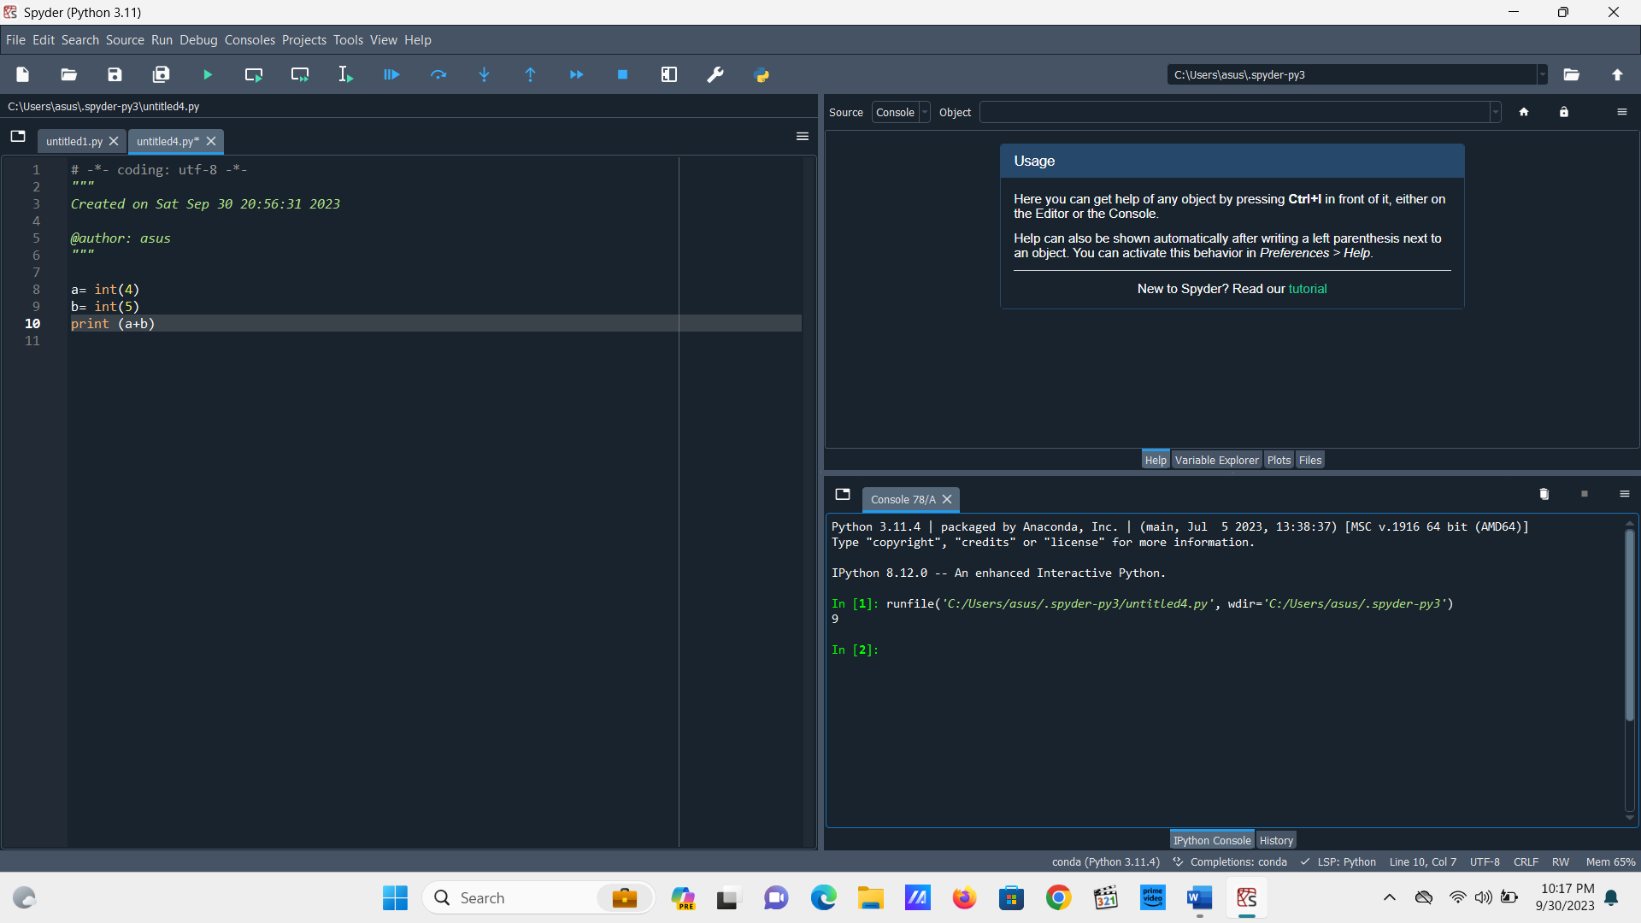

**11. Subtraction**

**a= int(4)**

**b= int(5)**

**print (a-b)**

**12. Division**

**a= int(40)**

**b= int(5)**

**print (a/b)**

13. Multiplication

a= int(40)

b= int(5)

print (a*b)

14. Name   
  
n = ('Ayush')

print('Welcome', (n), 'to Amity')

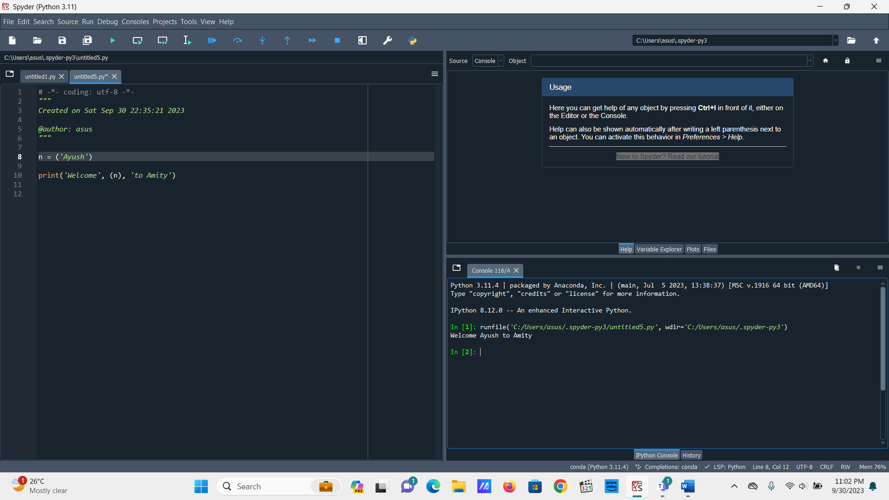

15. Quotient

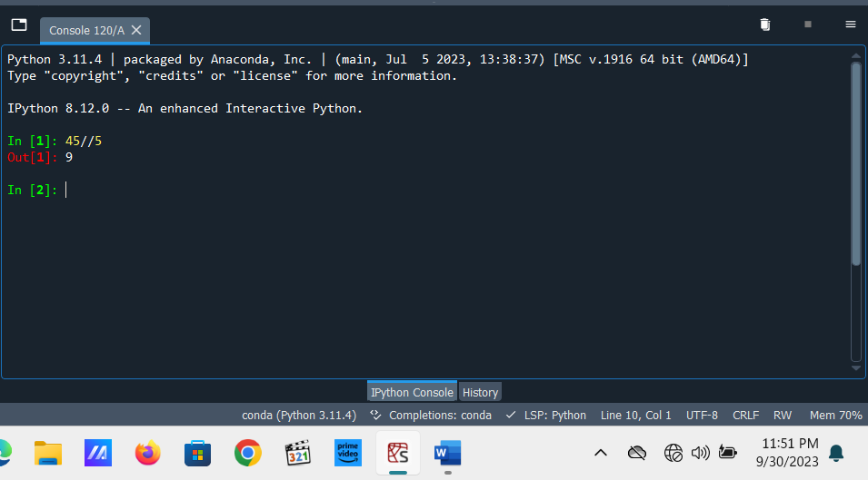

16. Remainder

